Identifying regime transitions for water governance at a basin scale

**Shuang Song, Shuai Wang, Xutong Wu, Yongping Wei, Graeme S. Cumming, Bojie Fu\***

**Abstract**

In many large river basins, the use and governance of rivers for socio-economic development has led to a global transformation from natural to social-ecological or ‘hydrosocial’ water regimes. Water governance decides who gets water, when, and how much. Identifying how and when water governance regimes change is therefore critical to understanding social-ecological water dynamics and guiding the efficient and sustainable use of water. We combined three main dimensions of water governance (supply, purpose and allocation) to develop a quantitative Integrated Water Governance Index (IWGI) that can detect regime shifts in water governance at a basin scale. Applying the index to a rapidly-changing large river basin (the Yellow River Basin, China) shows that it can describe shifts between three water governance regimes (respectively, massive supply regime; purpose-turned regime; and all-sided governance regime) over half a century, and offer a way to relate these shifts to environmental, economic social and political changes. Our application of the IWGI suggests a widespread transition schema for water governance regimes and a general transformative trajectory as a hypothesis for understanding hydro-social water cycles in the Anthropocene. The different governance challenges that occurred at different phases of the transition of the Yellow River also suggest potentially useful guidelines for the coordinated governance of big river basins in general.

**Significance Statement**

Development and maintenance of human societies depends on water. As natural water cycles are pushed by accelerating socio-economic processes towards a hydrosocial water cycle, big river basins are often governed phase by phase for further water use. We propose an integrated index to detect water governance regimes and apply it to the Yellow River Basin, a fast-changing basin. Three water governance regimes are identified (massive supply, purpose turned, and all-sided governance). They suggest a general regime-transition schema for large river basins. By linking river basin governance transitions with major water governance challenges, our approach can offer useful sustainability guidelines for big river basins all around the world.

**Main Text**

# Introduction

Water has been described as being “at the centre of the planetary drama of the Anthropocene” (1). It is essential, not only for earth system processes but also in supporting the economic development and continued wellbeing of human societies. Human activities stemming from our reliance on water have profoundly modified the natural water cycle, moving rivers along a trajectory towards a hydrosocial water cycle (2–5), in which social and power relations dominate the nature of hydrological cycles. Facing this major transformation, many of the world’s big river basins (which are hot spots of civilization and economic growth) are urgently in need of new models of water governance for sustainability (6–8). As an integral part of a proposed earth system governance framework, sustainable water governance requires a deep understanding of the complex relationships between people and water (8–10).

resources in populated areas A first important step in identifying transitions towards a hydrosocial water cycle is to identify the different regimes under which it occurs. According to the United Nations Development Programme (UNDP), three key dimensions of water use are decided by the water governance regime directly: “How much water can be used?” (supply), “How can different services provided by water be balanced?” (purpose), and “How can water be allocated equally and efficiently?” (allocation) (11–13). A regime is defined as a locally stable state of a system’s structure, function, and dominant controls. Large and persistent changes in key system properties may lead to a loss of local stability, potentially resulting in a regime shift with impacts on system outcomes and widespread cascading effects (14, 15). Regime shifts are both consequences and signals of substantive changes in water governance, and may lead to new challenges to sustainability (10).

In addition to being caused by changes in key environmental, economic, social and political variables, regime shifts in water governance can be triggered through changes in each of the three key dimensions of governance (supply, purpose, and allocation; 11–13). First, the *supply* of water depends not only on weather (with worrying long-term trends in many regions, such as the loss of glaciers) but also on the demands of economic activities such as irrigation and industry; water storage can resolve some but not all of these issues (16–18). Second, the *purposes* for which water is used are balanced between consumptive uses (e.g., drinking and food production) and non-consumptive uses (e.g., energy production or fisheries); water may also provide a range of different non-consumptive regulating and cultural services, such as waste disposal or scenic values (19, 20). Water governance can be viewed as the process of assigning weights to each of these different purposes and enforcing the resulting rules. Third, the *allocation* of water across the whole basin is influenced not only by regional environmental context but also by local socioeconomic trends and regions’ comparative economic advantages, which can be altered by changing social and political drivers (21, 22). Despite the obvious relevance of substantive changes in any of the three dimensions of water governance, the lack of a simple but comprehensive method for identifying changes in water governance regimes makes it difficult to achieve water governance for sustainability (Figure 1).

As an informative example, we focus on the The Yellow River Basin (YRB, see *Appendix* Methods S1 and Figure S1 for details). The YRB has experienced some of the most intense water use and dramatic regime shifts of any large river basin in China, giving rise to long-standing challenges for its governance. From about 550BC until half a century ago, flooding and the huge sediment loads of the Yellow River brought frequent human disasters and the constant shifts in the river’s channel made it difficult for people to use its waters (23, 24). Since the 1960s, the implementation of conservation measures, regulation reservoirs, and levee constructions have contained the issues caused by high-sediment loads (25, 26). However, water over-use has led to drying up of the Yellow River, creating new governance challenges that have been addressed through a range of related policies (e.g., regulating water use and limiting water withdrawals) (27). Today, given that it is still difficult to completely meet water demands and various trade-offs must be negotiated between regions and sectors, there is still a long way to go towards successful water governance (28, 29). All in all, therefore, the YRB has been among the most rapidly-changing large river basins in the world, with myriad responses to the endless governance challenges induced by environmental, economic, social and political factors. Identifying regime shifts in water governance within the YRB can thus provide crucial insights into the world’s rapidly-changing big river basins and the ways in which governance may respond to meeting challenges to their sustainability.

We first use the three key dimensions (supply, purpose and allocation) of water governance to develop an Integrated Water Governance Index (IWGI) that can detect and describe changes in water governance at a basin scale (**Figure****1**). Then, by applying the index to a typical rapid-changing big river basin (the YRB), we show how the index can be used to analyse the complicated regimes of water governance and their main causes in a comprehensive but simple way. Finally, we propose a general regime transition schema as a practical guideline for a coordinated approach to exploring the challenges faced by big river basin governance.

# Results

## Water governance regimes

With two significant breakpoints, the changes in the IWGI are divided into three periods (Figure 2A) with different slopes. The changes are contributed by different water governance dimensions (Figure 2B). In the first period (P1, 1965-1978), the IWGI increased rapidly. Water supply made the most striking positive contribution (131%), while purpose and allocation had a slight negative contribution (-11% and -20%). In the second period (P2, 1979-1994), the contributions of purpose and allocation became positive and the IWGI experienced a drop because steeply declining supply capacity played a larger negative role (dropping to -188% lower than P1). In the third period (P3, 1995-2013), as positive contributions from purpose (75%) and allocation (84%) increased further and the negative contribution of water supply lessened (-59%), positive growth of the IWGI returned.

Each period has a unique most striking positive contributor to IWGI. Overall features of the three dimensions in different periods are shown in Figure 3. Throughout P1, the water governance regime was dominated by increasing supply capacities. It then experienced a shift, slowing down in increasing supply during P2, with an accompanying reverse in the contributed proportion between purpose and allocation. Finally, the contribution of all three dimensions was similar in P3 (32.91%, 31.87% and 35.21% for purpose, allocation and supply respectively), making the points cluster at the centre of the diagram. The three different periods corresponded to three distinct water governance regimes: a massive supply regime (P1: 1965-1978), a purpose-turned regime (P2: 1979-1993), and an all-sided governance regime (P3: 1994-2013).

## Causes of water governance regime shifts

Digging more deeply into the underlying causes of changes in the IWGI, the expansion of irrigated area and the economic growth of industry and services were key to the change in purpose between P1 and P2. During P1, the area of irrigated agriculture in the Yellow River Basin expanded rapidly at a rate of (Figure 4 A), and irrigation water was the dominant water use ( of the total water use in 1965, and in 1978, *SI Appendix* Fig. S3). Entering P2, however, the expansion of irrigated area stalled and industry and services gradually took off, with more water demands (Figure 4B) leading to an reduction in the proportion of irrigation water use (*SI Appendix* S3).

The efficiency of water use changed from P2 to P3. While irrigated area resumed its expansion again in P3 (Figure 4A), industry and urban services assumed a stronger economic role (represented by Gross Added Values, GVA) (Figure 4B). However, because of more efficient technology and better water conservation practices (*SI Appendix* Fig. S4), both experienced significant declines in water use intensity (WUI) for unit production (Figure 4A and Figure 4B). As a result, the differences between sectors of water use were reduced while the total water consumption remained stable during P3 (*SI Appendix* Fig. S3).

Finally, environmental context, social transformation and water governance policies played roles in all three regimes. We calculated the ratios of regional and basinal water use for each reservoir (R/B ratio), with a higher ratio representing a potential role for supply rather than regulation (Figure 4C). Under the guiding ethos of “ conquering nature”, most of the reservoirs were built in regions with high water demands during P1, when natural water resources were relatively abundant (*SI Appendix* Fig. S5) and R/B ratios were significantly higher (Figure 4C, p<0.01). In P2, the number of new reservoirs decreased significantly and allocation of water was rigorously controlled by “the 87 Water Diversion Scheme”, with little increase in total water storage capacity (*SI Appendix* Fig. S6). Entering P3, myriad national-level water governance policies were proposed under the guide of “environmental regulation” (Figure 4D), and the number of new reservoirs was even higher for facilitating and regulating objectives. Most of these were built in regions with lower R/B ratios (Figure 4C and *SI Appendix* Fig. S6).

# Discussion

## Water governance challenges along transition regimes

Our results show that there have been three distinct but sequential governance regimes within the YRB (Figure 3): a massive supply regime (1965-1978), a purpose-turned regime (1979-1993) and an all-sided governance regime (1994-2013). Shifts between these regimes were caused by different environmental, economic, social or political drivers (Figure 4). It is important to note that each regime occurred gradually, with multifaceted causes, as the basin moved towards a hydrosocial water cycle. The challenges were primarily economic and environmental at the beginning of the YRB’s water governance trajectory and social and policy-related towards the end (Figure 5).

During the massive supply regime (1965-1978), the basin economy was mainly dependent on agriculture and natural water resources were relatively abundant (*SI Appendix* Figure S5); water governance thus tended to supply more resources for agriculture (e.g., by construction of reservoirs and channels). Due to the limited effects of socio-economic feedbacks on this regime, water governance had few protective policies, assumed an unlimited water supply, and took little consideration of the impacts of water use on social equity and the environment (30). Since nearly 80% of surface water was used (mainly for provisioning purposes), the Yellow River dried up during the second half of the regime (*SI Appendix* Figure S7). Ecological issues, such as wetland shrinkage and declines in biodiversity, emerged as the drying up became more and more serious, leading a huge social-ecological crisis and a significant challenge to existing modes of water governance (29).

The start of the purpose-turned regime (1978) coincided with Chinese “reform and opening-up”. This huge social transformation led to the emergence of industry and services, broke the dominance of agriculture, and resulted in higher competition for water use (Figure 4 and *SI Appendix* Fig. S8). In the face of ongoing environmental challenges and new economic challenges, the Yellow River Conservancy Commission (*SI Appendix* Methods S1) underwent a reorganization and received instructions from the Ministry of Water Resources (then called the Ministry of Water Resources and Electric Power) to resume and strengthen work on hydrology and basin management in the YRB (31). As a result, new policies and regulations (e.g., “the 87 Water Diversion Scheme”) were introduced in the YRB ahead of the rest of the country to allocate water and successfully stop the expansion of irrigated water consumption (32).

The next shift, to the all-sided governance regime, did not occur until a significant increase in water use efficiency in about 1993 overcame some resource limits (33). Since socio-economic trade-offs between water-dependent regions and sectors played a more important role at this regime, water governance had to achieve efficient water allocation while balancing different purposes in the face of limited water supply (34). For example, the water rights conversion project that has been popularized during this regime may even save regional agricultural water for industrial developments in other regions; and water transfer has been another huge project to meet water demands within the YRB (35, 36). On the other hand, the old water policy (e.g., “The 87 Water Diversion Scheme”), which once helped the YRB resolve its environmental crisis, limited social equity and coordinated allocation under the new regime because of path dependence (32). Many national-level water policies were proposed or adjusted under this regime, as the absence of such policies and social injustice in water use became new structural challenges for governance (37).

In general, shifts between the three governance regimes occurred sequentially during a transformation towards the hydrosocial cycle. Transition from biophysical control to social and political control of ecosystem dynamics may become increasingly widespread in social-ecological systems as increasing anthropogenic impacts gradually change the world (38–40). Some of the implications of this kind of change, when accompanied by engineering solutions, have been explored in the Millennium Assessment’s ‘Technogarden’ scenario (MA Refs). The transition regimes identified here echo the two kinds of major water governance challenges globally (resource challenges and structural challenges, Figure 5 and *SI Appendix* Fig. S9) (41, 42). Resource challenges, represented as water shortage and water supplying difficulties, are mainly faced by undeveloped and developing basins and are highly related to economic and environmental change (20, 43, 44). Alternatively, highly-controlled and developed basins (especially for transboundary rivers) must mainly resolve structural challenges, such as water disputes or lack of equity, and may be in urgent need of novel flexible, efficient sociopolitical governance structures (21, 45, 46). It is typical that resource challenges and structural challenges have occurred sequentially during the transition of water governance within the YRB. Our analysis thus suggests that the initial phase of transition often leads to resource-focused challenges that result from economic, demographic, and environmental change; while later phases are dominated by structural challenges relating to social and political aspects of governance. From the perspective of the core dimensions emphasized by the UNDP for water governance, our proposed schema connects governance challenges and the transformation of large river basins towards a hydrosocial water cycle.

[if space permits:] Additional challenges are raised by the process of upscaling that occurs as river basins transition between regimes. Under the influence of economic forces, water use gradually changes from being a primarily local concern to becoming a national or international concern, with large river basins being critical sources of ecosystem services, economic development, and human wellbeing. Successful navigation of water regime transitions through an upscaling process requires a corresponding upscaling in the governance regime and the creation of higher-level institutions that can regulate and manage cross-scale effects. (example from the YRB – e.g., tradeoffs between income for local farmers vs national growth needs supported by water-dependent industries?)

## Implications and future directions

The IWGI index captures the transitional regimes of water governance in a relatively simple but comprehensive way. It is important for scientists and decision makers to recognize the changing governance challenges, because development is not a panacea for all basin issues regarding sustainability (39, 47). Models and approaches developed under one regime are not necessarily useful under a different regime. For today’s world, water-related challenges remain one of the major gaps in our progress towards sustainability, while development-first strategies are still a dominant guideline in many places and may be in opposition to improving governance (16, 19, 48). Although most large river basins have shown improvements in water management technologies and water use efficiency along with development, freshwater use is still considered to be approaching planetary boundaries where human-water systems may collapse (49–51). Overall, there are probably two main reasons for this apparent failure of governance. First, significant improvement in agricultural irrigation efficiency is usually accompanied by a re-expansion of irrigated area, resulting in an unabated trend of water resources stress (the paradox of efficiency) (52). Second, without successful governance, complicated governance structures dominated by hydrosocial water cycles may result in less flexible water use and undermine the resilience of social-ecological systems at a basin scale (5, 18, 53). From these perspectives, we need better and more comprehensive strategies to address governance challenges because the core problems are complex and difficult to manage (9, 10, 54, 55). A deeper understanding of governance that incorporates ideas of non-liner change, regimes, and transitions should help to shift the focus of governance towards maintaining the resilience of the basin’s social-ecological system and improving its sustainability.

# Methods

We constructed the Integrated Water Governance Index (IWGI) based on three dimensions (supply, purpose, allocation, see Figure 1) and identified the changes periods of the index over time by change points detection. Each dimension is reflected by an independent indicator after normalization, and water governance regimes were characterized by the combination of impacts along each dimension at different time periods. The contribution to changes of IWGI index along with each main indicator were also decomposed and calculated separately for each regime period.

## Integrated Water Governance (IWGI)

Water resources governance system is closely related to a transformation towards a hydrosocial water cycle in the three dimensions below (see *SI Appendix* Methods S4 for details) (4, 5, 56):

* Socio-economic dominance may lead to further demands on the water supply (S) because of increasing water withdrawals. However, since effective water governance may boost supply capacities to meet water demands by technical solutions in the process of development:
* Transformation is usually accompanied by a change of purpose in water governance towards socio-economic services (usually towards non-provisioning purposes), because of higher returns:
* Transformation usually leads to more complicated structures in water allocation, as a result of division and cooperation between regions and sectors because of environmental context and economic comparative advantages:

We combined these three dimensions into a single integrated index, keeping their positive or negative relationship with the transformation towards a hydrosocial water cycle:

To effectively represent the three dimensions, we selected an appropriate indicator (, , or corresponding to supply, purpose, and allocation respectively) for each dimension. Then, the above equation was transformed into a natural logarithm to facilitate calculation:

Assuming they have equal weights, the Integrated Water Governance Index (IWGI) is:

where is a normalization of log-transformed indicator for a certain dimension:

### Normalization

We tested different normalization methods and they made no difference in change point detection (see *SI Appendix* Methods S5. Sensitivity analysis). We performed min-max normalization using the formulation below:

### Indicator of Stress

We used the scarcity-flexibility-variability (SFV) water stress index proposed in Qin et al., 2019 to evaluate water supply capacities () as the indicator in a certain region (18). This metric takes into account management measures (such as the construction of reservoirs) and the impact of changes in the industrial structure of water use on the evaluation of water scarcity (see *SI Appendix* Methods S4 for details). For the whole YRB, the indicator of supply capacity is the average of all regions’ SFV-index:

Where is the SFV-index for region , and to refers SR, UR, MR, and DR (see *SI Appendix* Methods S1 Definition of study area).

### Indicator of purpose

To quantify purpose , we used Non-Provisioning purpose Shares (NPS) of water use as an indicator. While provisioning purpose water use () includes domestic, irrigated and livestock water uses, non-provisioning purpose water use () includes industrial and urban services water uses. We calculated the NPS as:

Where refers a certain region, or the whole basin, i.e:

=

### Indicator of allocations

To describe allocations , we designed an indicator based on information entropy, called allocation Entropy Metric (CEM). CEM measures the degree of evenness of water allocation (see *SI Appendix* Methods S4). Our indicator was intended to reflect the idea that with the development of society, water resources allocation becomes more balanced among regions and generally meets the needs of different sectors, but different regions have a trend of division of labour among various sectors (with larger gaps):

where and are allocation Entropy Metric in different regions and different sectors. describes differences between sectors in a certain region relative to the whole basin (see *SI Appendix* Methods S4).

## Change points detection

With no assumptions about the distribution of the data, the Pettitt (1979) approach of change-point detection is commonly applied to detect a single change-point in hydrological time series with continuous data (57). It tests : The variables follow one or more distributions that have the same location parameter (no change), against the alternative: a change point exists. The non-parametric statistic is defined as:

Where:

The change-point of the series is located at , provided that the statistic is significant. We used 0.001 as the threshold p-value (see *SI Appendix* Methods S5 for Sensitivity analysis), meaning that the probability of a statistically significant change-point judgment being valid was more than . Since this method can only return one significant change point, we repeated it until all significant change points were detected.

## Contribution decomposition

We decomposed the amount of variation in each index at different periods in order to quantify the contribution of each influence to the index. Using the Integrated Water Resources governance (IWGI) Index as an example, its value is influenced by normalized indicators in three dimensions: stress (), purpose () and allocation (). We can calculate their differences between two certain years ( and , ) by:

Then, the contribution of dimension to IWGI’s changes can be referred as:

## Datasets

In order to calculate IWGI, we need to calculate multiple indicators and sub-indicators. All the datasets used are listed in the *SI Appendix* table S1. A detailed description of the data is provided in the supplementary materials *SI Appendix* Methods S2.

# References

1. T. Gleeson*et al.*, Illuminating water cycle modifications and Earth system resilience in the Anthropocene. *Water Resources Research* **56** (2020).

2. M. Sivapalan, H. H. G. Savenije, G. Blöschl, Socio-hydrology: A new science of people and water: INVITED COMMENTARY. *Hydrological Processes* **26**, 1270–1276 (2012).

3. D. Qin*et al.*, Theoretical framework of dualistic natureSocial water cycle. *Chinese Science Bulletin* **59**, 810–820 (2014).

4. B. W. Abbott*et al.*, A water cycle for the Anthropocene. *Hydrological Processes* **33**, 3046–3052 (2019).

5. D. F. Levia*et al.*, Homogenization of the terrestrial water cycle. *Nature Geoscience* **13**, 656–658 (2020).

6. J. Best, Anthropogenic stresses on the world’s big rivers. *Nature Geoscience* **12**, 7–21 (2019).

7. M. Falkenmark, L. Wang-Erlandsson, J. Rockström, Understanding of water resilience in the Anthropocene. *Journal of Hydrology X* **2**, 100009 (2019).

8. G. Di Baldassarre*et al.*, Sociohydrology: Scientific Challenges in Addressing the Sustainable Development Goals. *Water Resources Research* **55**, 6327–6355 (2019).

9. F. Biermann*et al.*, Navigating the Anthropocene: Improving Earth System Governance. *Science* **335**, 1306–1307 (2012).

10. W. Steffen*et al.*, The emergence and evolution of Earth System Science. *Nature Reviews Earth & Environment* **1**, 54–63 (2020).

11. UNDP Water Governance Facility, D. H. Tropp, D. A. Jiménez, “Water governance in perspective: Water Governance Facility 10 years 2005-2015” (Water Governance Facility, 2015).

12. UNDP Water Governance Facility, Ingvild Oia, Paavani Reddy, Håkan Tropp, Håkan Tropp, *User’s guide on assessing water governance* (United Nations Development Programme, 2013).

13. UNDP Water Governance Facility, “Water Governance: Issue Sheet” (2016).

14. J. C. Rocha, G. Peterson, Ö. Bodin, S. Levin, Cascading regime shifts within and across scales. *Science* **362**, 1379–1383 (2018).

15. E. J. Gregr*et al.*, Cascading social-ecological costs and benefits triggered by a recovering keystone predator. *Science* (2020) <https:/doi.org/10.1126/science.aay5342>.

16. P. Greve*et al.*, Global assessment of water challenges under uncertainty in water scarcity projections. *Nature Sustainability* **1**, 486–494 (2018).

17. Y. Wada*et al.*, HumanWater interface in hydrological modelling: Current status and future directions. *Hydrol. Earth Syst. Sci.*, 26 (2017).

18. Y. Qin*et al.*, Flexibility and intensity of global water use. *Nature Sustainability* **2**, 515–523 (2019).

19. J. Liu*et al.*, Water scarcity assessments in the past, present, and future. *Earth’s Future* **5**, 545–559 (2017).

20. M. Flörke, C. Schneider, R. I. McDonald, Water competition between cities and agriculture driven by climate change and urban growth. *Nature Sustainability* **1**, 51–58 (2018).

21. M. Roobavannan, J. Kandasamy, S. Pande, S. Vigneswaran, M. Sivapalan, Role of Sectoral Transformation in the Evolution of Water Management Norms in Agricultural Catchments: A Sociohydrologic Modeling Analysis: ECONOMIC DIVERSIFICATION IN WATER USEAGE. *Water Resources Research* **53**, 8344–8365 (2017).

22. R. Speed, Y. Li, T. L. Quesne, *Basin Water Allocation Planning: Principles, Procedures and Approaches for Basin Allocation Planning* (Asian Development Bank, 2013).

23. S. Song*et al.*, Sediment transport under increasing anthropogenic stress: Regime shifts within the Yellow River, China. *Ambio* **1** (2020).

24. C. Li, Y. Zhang, Y. Shen, Q. Yu, Decadal water storage decrease driven by vegetation changes in the yellow river basin. *Science Bulletin* (2020) <https:/doi.org/10.1016/j.scib.2020.07.020>.

25. S. Wang*et al.*, Reduced sediment transport in the Yellow River due to anthropogenic changes. *Nature Geoscience* **9**, 38–41 (2016).

26. X. Wu*et al.*, Evolution and effects of the social-ecological system over a millennium in China’s Loess Plateau. *Science Advances* **6**, eabc0276 (2020).

27. C. Xia, C. Pahl-Wostl, The Development of Water Allocation Management in The Yellow River Basin. *Water Resources Management* **26**, 3395–3414 (2012).

28. Y. Wang, W. Zhao, S. Wang, X. Feng, Y. Liu, Yellow River water rebalanced by human regulation. *Scientific Reports* **9**, 9707 (2019).

29. C. Wohlfart, C. Kuenzer, C. Chen, G. Liu, SocialEcological challenges in the Yellow River basin (China): A review. *Environmental Earth Sciences* **75**, 1066 (2016).

30. F. Zhou*et al.*, Deceleration of China’s human water use and its key drivers. *Proceedings of the National Academy of Sciences*, 201909902 (2020).

31. Y. R. Archives, *Organizational History of the Yellow River Conservancy Commission* (Yellow River Water Conservancy Press, 2004).

32. Y. Wang, S. Peng, G. Jiang, H. Fang, Thirty Years of the Yellow River Water Allocation Scheme and future Prospect. *MATEC Web of Conferences* **246**, 01083 (2018).

33. J. Liu*et al.*, Water conservancy projects in China: Achievements, challenges and way forward. *Global Environmental Change* **23**, 633–643 (2013).

34. C. Dalin, H. Qiu, N. Hanasaki, D. L. Mauzerall, I. Rodriguez-Iturbe, Balancing water resource conservation and food security in China. *Proceedings of the National Academy of Sciences* **112**, 4588–4593 (2015).

35. J. Barnett, S. Rogers, M. Webber, B. Finlayson, M. Wang, Sustainability: Transfer project cannot meet China’s water needs. *Nature News* **527**, 295 (2015).

36. X. Yunpeng, Y. Liangzhi, Water Right Transfer Experiment and the Impact on the Water Resources Management Policy In China: An Overview. *Business and Public Administration Studies* **5**, 52–52 (2010).

37. M. Konar, M. Garcia, M. R. Sanderson, D. J. Yu, M. Sivapalan, Expanding the Scope and Foundation of Sociohydrology as the Science of Coupled Human-Water Systems. *Water Resources Research* **55**, 874–887 (2019).

38. J. Best, S. E. Darby, The Pace of Human-Induced Change in Large Rivers: Stresses, Resilience, and Vulnerability to Extreme Events. *One Earth* **2**, 510–514 (2020).

39. G. S. Cumming, S. von Cramon-Taubadel, Linking economic growth pathways and environmental sustainability by understanding development as alternate social-ecological regimes. *Proceedings of the National Academy of Sciences* **115**, 9533–9538 (2018).

40. G. S. Cumming *et al.*, Implications of agricultural transitions and urbanization for ecosystem services. *Nature* **515**, 50–57 (2014).

41. A. Singh, D. Saha, A. C. Tyagi, Eds., *Water Governance: Challenges and Prospects* (Springer Singapore, 2019) <https:/doi.org/10.1007/978-981-13-2700-1>.

42. S. Porcher, S. SAUSSIER, Eds., *Facing the Challenges of Water Governance* (Palgrave Macmillan, 2019) <https:/doi.org/10.1007/978-3-319-98515-2>.

43. J. R. Allan*et al.*, Navigating the complexities of coordinated conservation along the river Nile. *Science Advances* **5**, eaau7668 (2019).

44. J. Liu, W. Yang, Water Sustainability for China and Beyond. *Science* **337**, 649–650 (2012).

45. N. Kitroeff, “This Is a War”: Cross-Border Fight Over Water Erupts in Mexico. *The New York Times* (2020).

46. UNEP-DHI, UNEP, UNEP, *Transboundary River Basins: Status and Trends* (2016).

47. B. Reyers, C. Folke, M.-L. Moore, R. Biggs, V. Galaz, Social-Ecological Systems Insights for Navigating the Dynamics of the Anthropocene. *Annual Review of Environment and Resources* **43**, 267–289 (2018).

48. Z. Xu*et al.*, Assessing progress towards sustainable development over space and time. *Nature* **577**, 74–78 (2020).

49. M. Li*et al.*, Exploring consumption-based planetary boundary indicators: An absolute water footprinting assessment of Chinese provinces and cities. *Water Research* **184**, 116163 (2020).

50. I. E. M. de Graaf, T. Gleeson, L. P. H. (Rens) van Beek, E. H. Sutanudjaja, M. F. P. Bierkens, Environmental flow limits to global groundwater pumping. *Nature* **574**, 90–94 (2019).

51. X. Huggins*et al.*, “The social-ecological dimensions of changing global freshwater availability” (EarthArXiv, 2020) <https:/doi.org/10.31223/osf.io/j97ud>.

52. R. Q. Grafton*et al.*, The paradox of irrigation efficiency. *Science* **361**, 748–750 (2018).

53. G. Grill*et al.*, Mapping the world’s free-flowing rivers. *Nature* **569**, 215–221 (2019).

54. R. Muneepeerakul, J. M. Anderies, The emergence and resilience of self-organized governance in coupled infrastructure systems. *Proceedings of the National Academy of Sciences* **117**, 4617–4622 (2020).

55. Ö. Bodin, Collaborative environmental governance: Achieving collective action in social-ecological systems. *Science* **357**, eaan1114 (2017).

56. W. Steffen*et al.*, Trajectories of the Earth System in the Anthropocene. *Proceedings of the National Academy of Sciences* **115**, 8252–8259 (2018).

57. A. N. Pettitt, A Non-Parametric Approach to the Change-Point Problem. *Journal of the Royal Statistical Society. Series C (Applied Statistics)* **28**, 126–135 (1979).

# Figures

## Figure 1

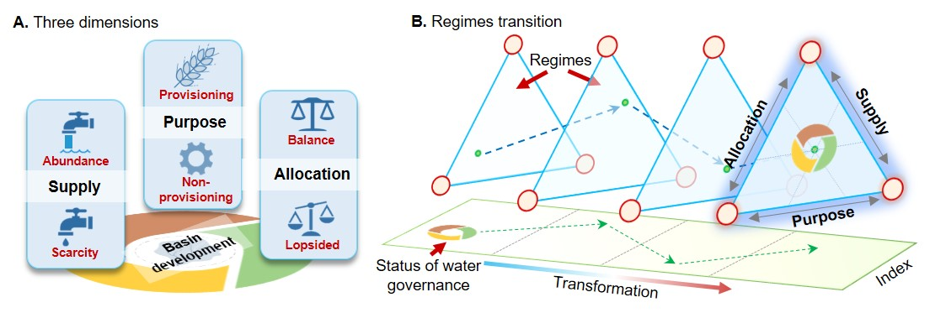

**Figure 1.** A framework for understanding the relationship between transitional water governance regimes and eventual transformation to a hydro-social cycle. A key missing element in current knowledge is an ability to detect regime shifts using a simple and comprehensive index. **A**: there are three key dimensions (supply, purpose and allocation) of water governance (see Methods for details). Each dimension has two poles (denoted in red) which indicate the two potential directions of changes along that axis: (1) “supply” shifts between scarcity and abundance. (2) “purpose” is weighted between consumptive services or non-consumptive uses. (3) “allocation” changes between balanced or lopsided. **B:** governance changes are an emergent outcome of trends across the three dimensions. Water governance status changes along a trajectory towards a hydro-social water cycle. When abrupt change occurs, it may indicate a regime shift in water governance.

## Figure 2

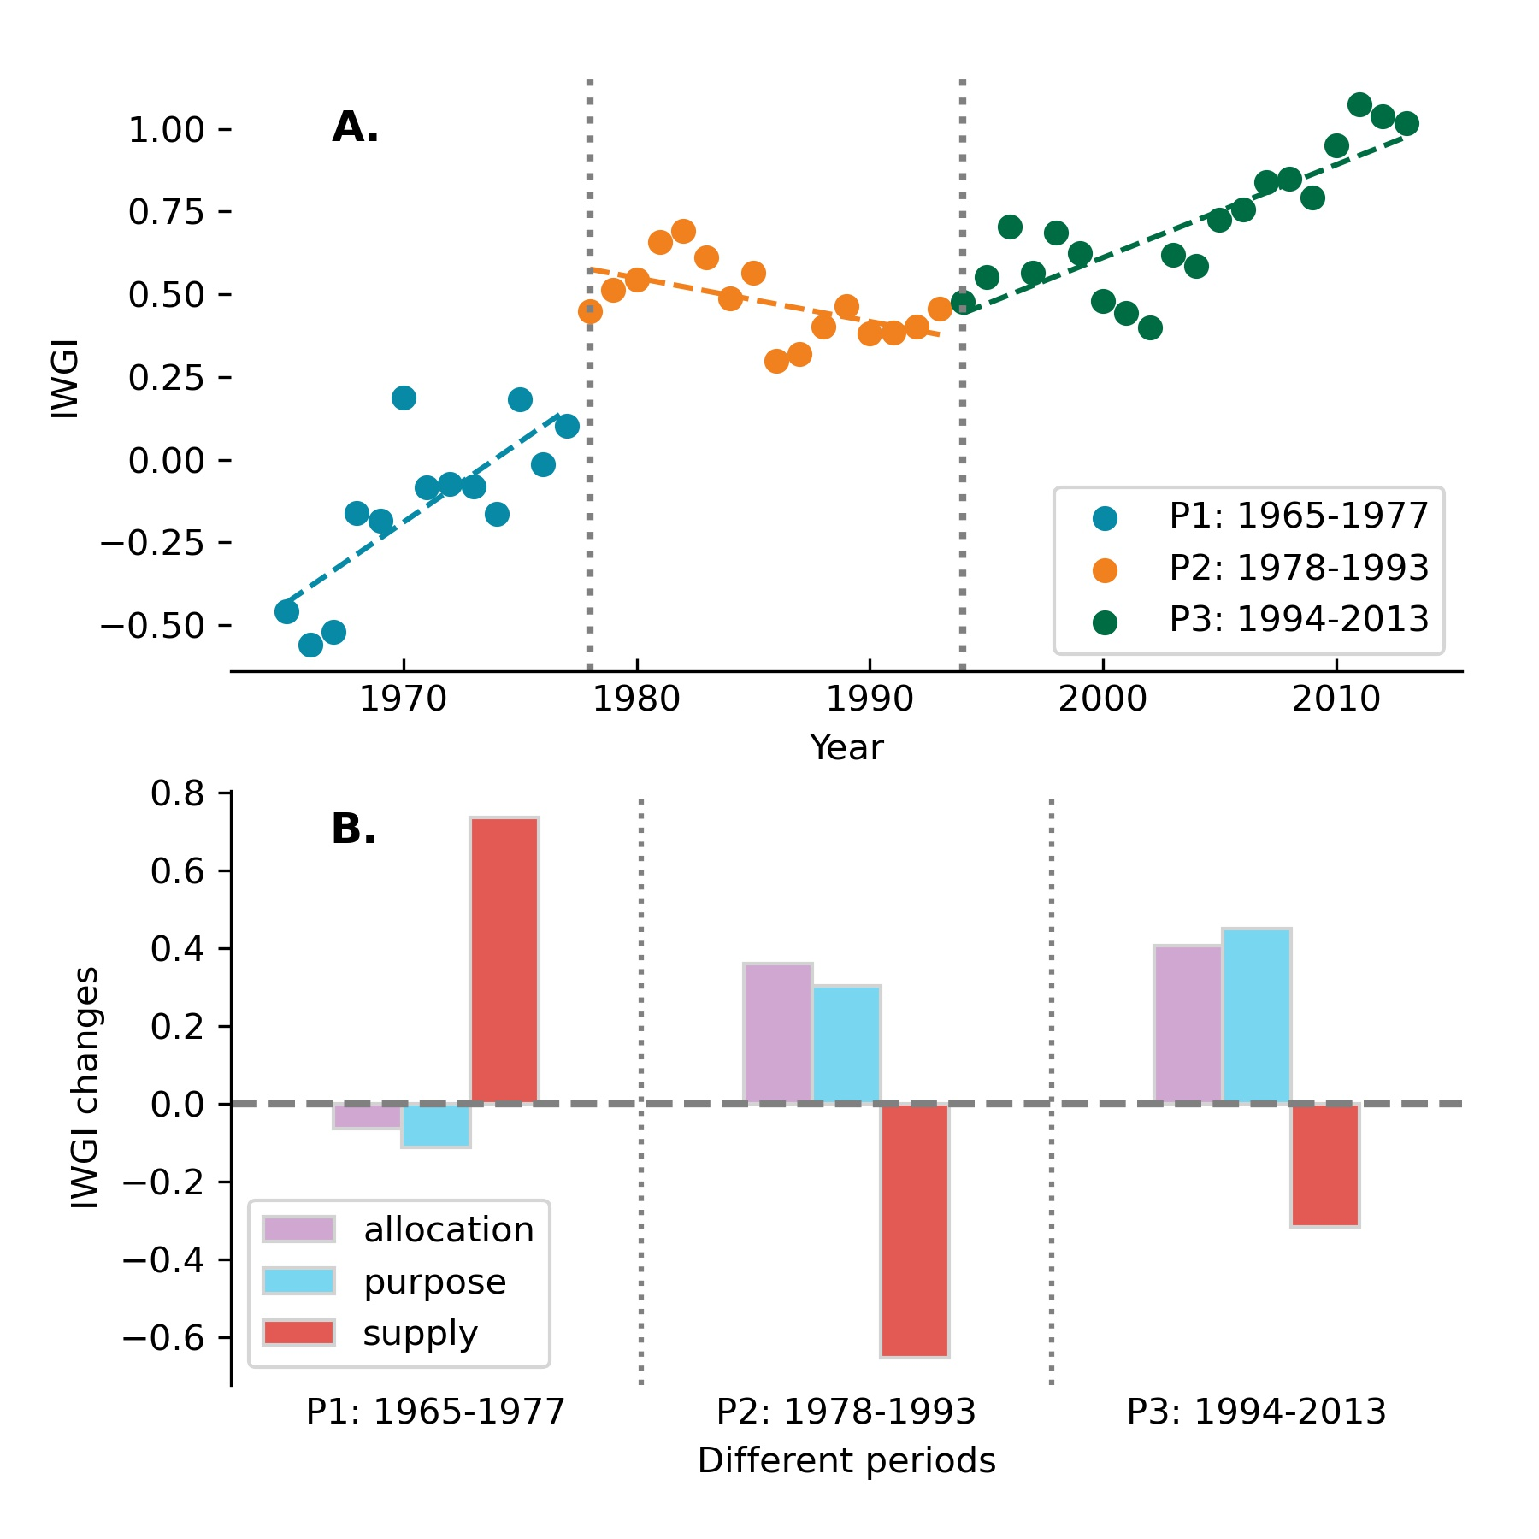

**Figure 2.** Changes in the IWGI index. **A,** Change points detection. With significant change points in 1978 and 1994, the IWGI has three different periods. **B,** Contributions of each dimension to the changes of IWGI within each of the three periods. Supply, purpose and allocation were respectively the main positive contributors to P1, P2 and P3.

## Figure 3

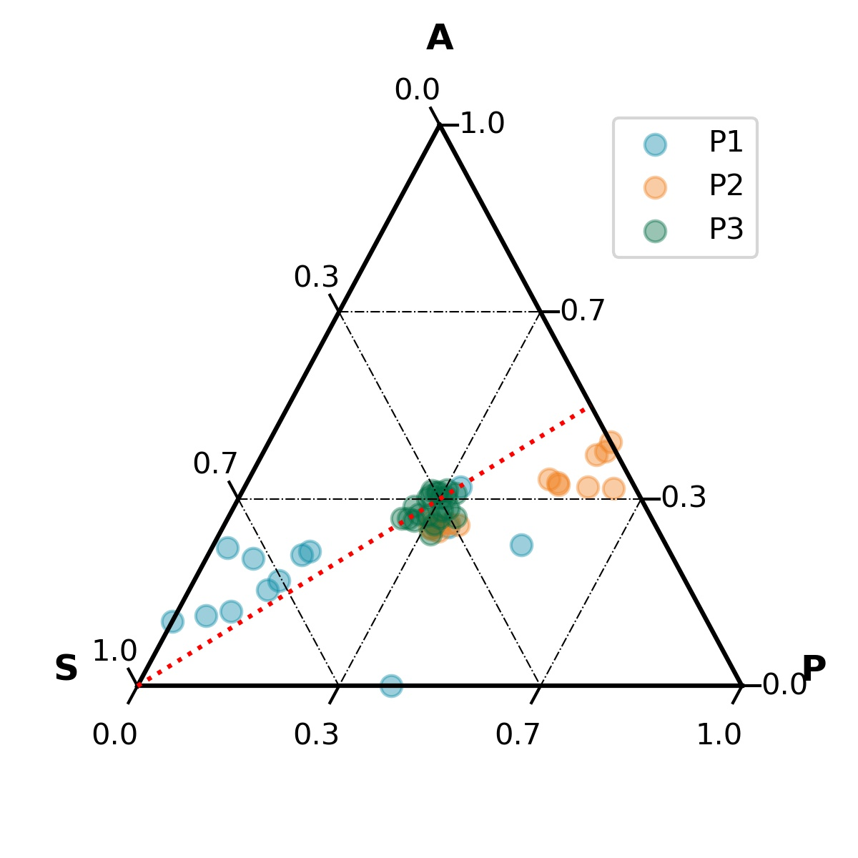

**Figure 3.** Combination of contributions across three dimensions in different periods (S: supply; P: purpose; A: allocation). The closer a point is to an angle of the outside triangle, the greater the proportion of the contribution of this dimension. The red indicator line in this plot denotes a 1:1 contribution between purpose (P) and allocation (A). When the points are below this line, the contribution ratio of allocation is lower than that of function, and vice versa.

## Figure 4

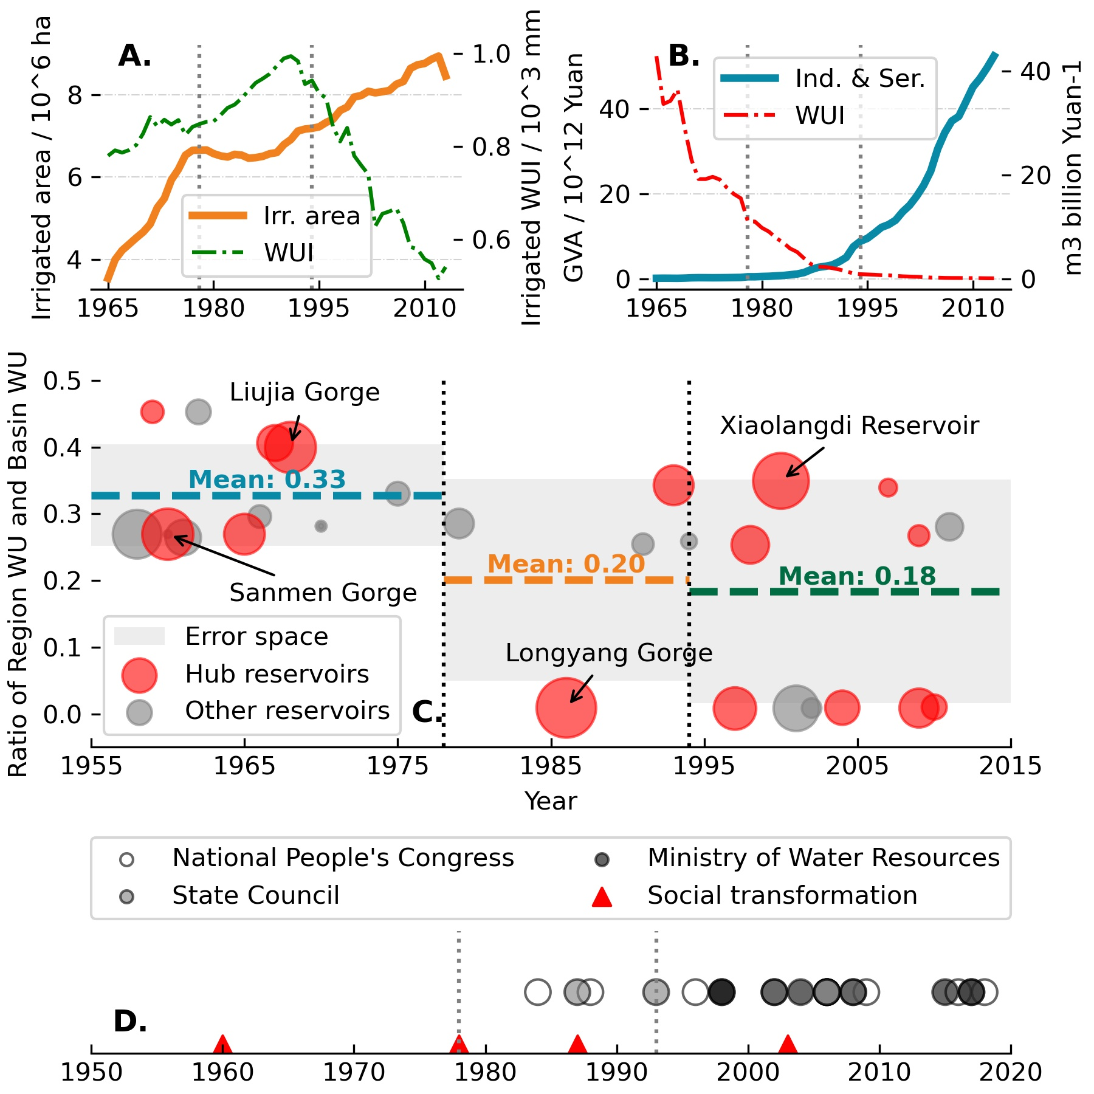

**Figure 4.** Causes of water governance regime shifts in the Yellow River Basin: environmental change, economic growth and efficiency changes, social transformation, and water governance policies. **A.** Changes in total irrigated area (orange line), and water consumption per unit of area (SI Appendix Methods S2). **B.** Changes in gross values added (GVA) of industry and services (blue line), and their water use intensity for unit production (WUI, red dotted line) respectively (SI Appendix Methods S2). **C.** Completed time of each new reservoir and their surrounding region’s water use percentages as a proportion of the basin’s total water use (WU) at that time. Red circles denote hub reservoirs in the basin, which play a role in integrated basin water management. The size of each circle indicates the magnitude of its water storage capacity. Some important reservoirs include (1) Xiaolangdi reservoir and Sanmen Reservoir, which were constructed mainly for managing sediments; and (2) Impoundments at Liujia Gorge and Longyang Gorge, which were constructed mainly for managing flood water discharge and water supply. The named reservoirs are significant for the entire basin, not only for regional development. **D.** Social transformations and national-level policies related to water governance (see SI Appendix Methods S1 and Table S2). In order, the four transformations are “ethos of conquer nature (since 1958)”, “reform and opening-up (since 1978)”, “the 87 Water Diversion Scheme (since 1987)”, “environmental regulation (since 2003)” (see SI Appendix Methods S1).

## Figure 5

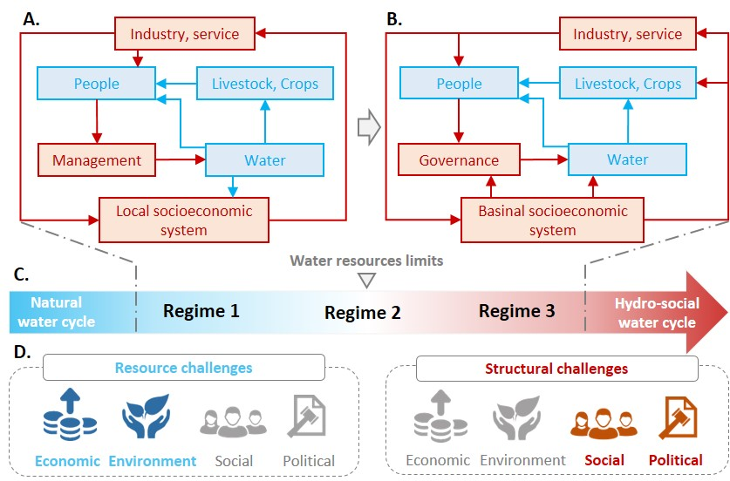

**Figure 5.** Transition schema of water governance during transformation towards a hydrosocial water cycle. Blue pathways are dominated by natural water cycle while red pathways are dominated by socio-economic feedbacks. There is a transformation towards the hydrosocial water cycle where red loop increases. **A. Early phase.** As socio-economic systems develop, industry and services gradually demand increasing amounts of water; at the same time, increasing social organization and technological capacity allow people to manage water resources more intensively, including intensive intervention in the natural water cycle. **B. Late phase**. With further developed and economically efficient industries and services, trade-offs between provisioning and non-provisioning water use become prominent. Rather than being determined by local socio-economic systems, water withdrawals and management are scaled up to the entire basin. Thus, **C. Transformation from a natural water cycle towards the hydro-social water cycle** occurs in paralleled with a transformation towards a hydrosocial water cycle. This is generally distinguished when water resource limits are reached. The three water governance regimes seen in the YRB are identified along this transition (Regime 1: massive supply regime, Regime 2: purpose-turned regime, Regime 3: all-sided governance regime). **D. Water governance challenges**. Through the transitional regimes, water governance faces primarily economic and environmental challenges in the early phase and social and policy challenges in the later phase.